Important layer:
Transport Layer
Tcp =transmission control protocol
- Connection-oriented
- Reliable
- Ordered data transfer
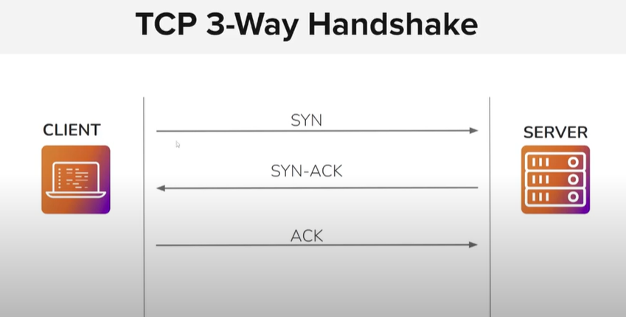
Client Initial sequence number =isn (syn) ----sent to server----
Server ack (Isn+1 ) + syn(own isn) -----sent to client by server-------
Client server-ack(isn+1) -----send to client------
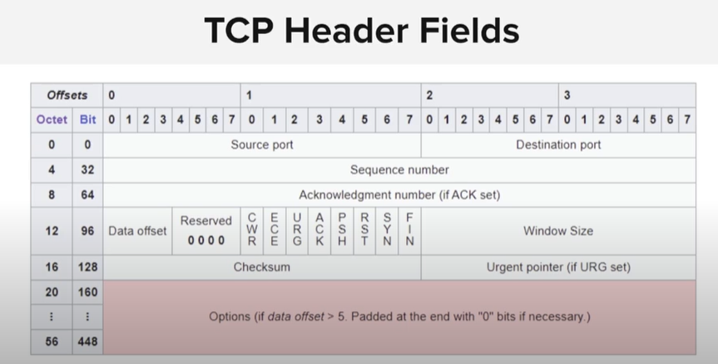
Flags in the tcp communication:
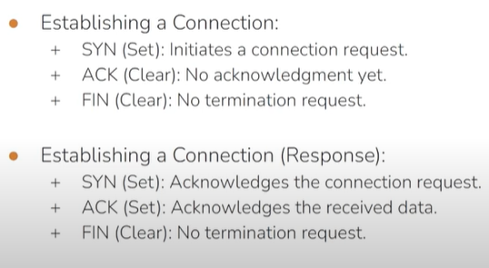
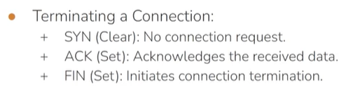
Reserved Ports:
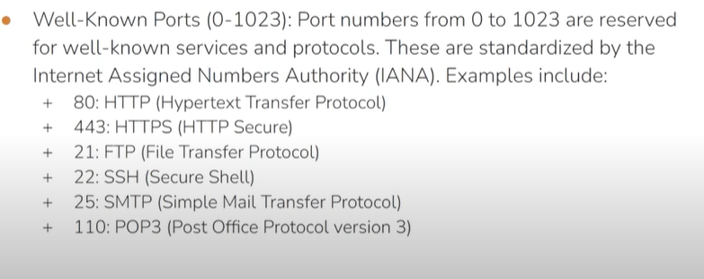
Telnet=23
We can also run other services on them but they are recommended.

Registered ports:
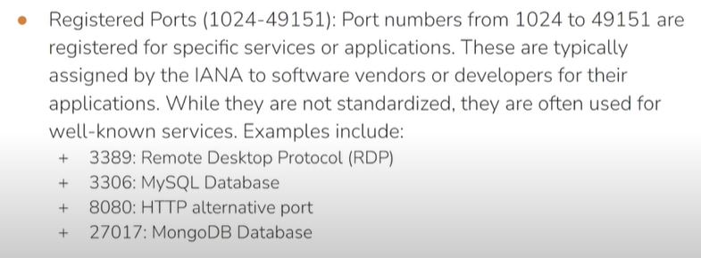

For a penetration tester it is important that you know that which service run on which port.

Udp= user datagram protocol
Connectionless
Unrealible
Real time application: voip,audio/video stream,online gaming
Simple and stateless

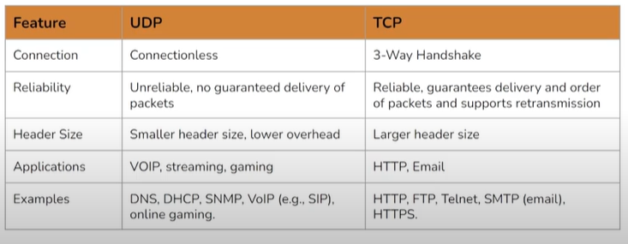

✅ Use netstat when you want to:
- See open/listening ports
- Check active TCP/UDP connections
- Find which app is using a port

netstat -antp
Flag | Meaning
-a | Show all connections (both listening and established)
-n | Show numerical addresses and ports (no DNS resolution)
-t | Show only TCP connections
-p | Show the PID and name of the program using the connection (requires sudo)

✅ Use Wireshark when you want to:
- Inspect actual traffic (e.g., HTTP requests, DNS queries)
- Analyze protocols in detail
- Capture and replay communication

The 3 way handshake in the wireshark:
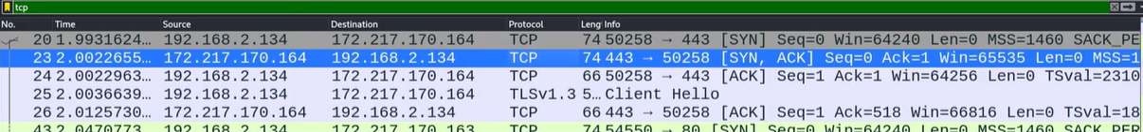

Then we have to check one by one 3 of them in :
First packet:
Flag set:
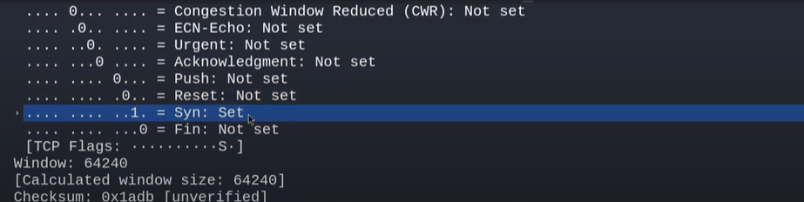
Then check the sequence number:
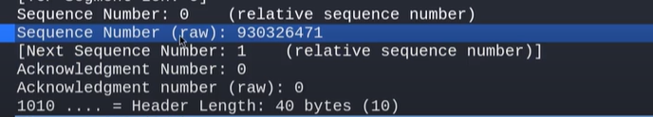

Second packet:
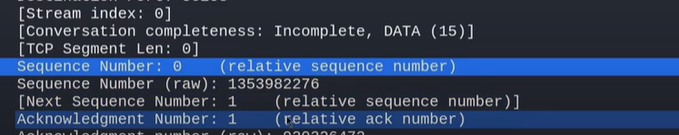
Then flags:
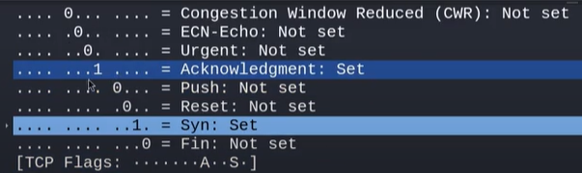
2 flags are set in the 2 packet.

third packet:
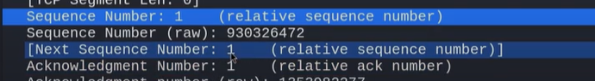
Flag:
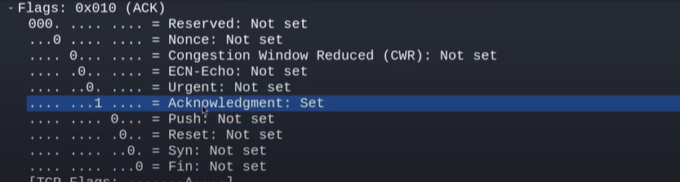
DONE

The next packet tls:
The TLS only happen after the tcp connection established.
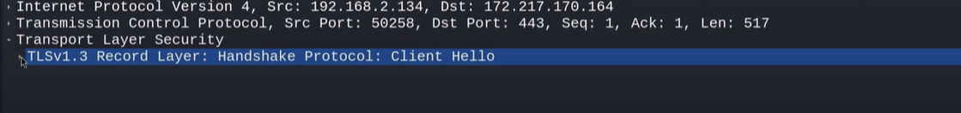
Another layer as we are deal with it.
This is the session layer.
OSI Layer | Role | TLS Involvement
Layer 6 – Presentation | Data formatting, encryption, compression | ✅ TLS handles encryption here
Layer 5 – Session | Establishing, managing sessions | ⚠️ TLS helps create secure sessions
Layer 7 – Application | Applications like HTTPS, SMTP, IMAP | 🔄 TLS secures Layer 7 protocols

🕓 RTT is the time it takes for a packet to go from your computer to a destination and back again.

